Name: R.Yaswanth
Reg No: 192572023
Course Name: Computer Networks for Software Application
Code: CSA0713

10. Making Computer Lab in Cisco Packet Tracer.

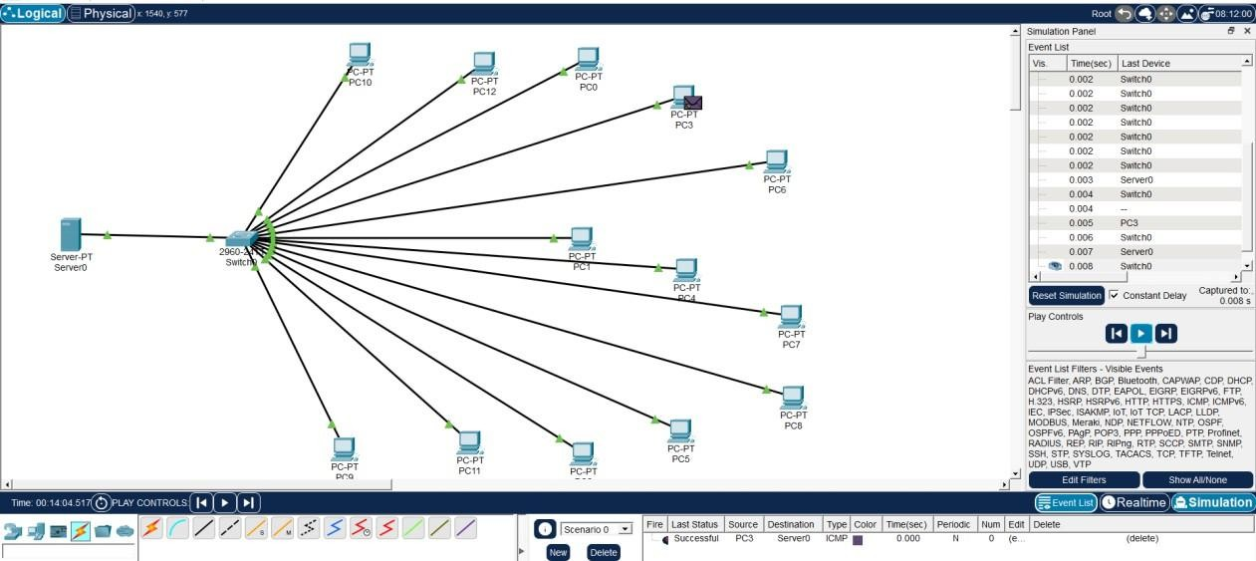

11.Designing two different network with Static Routing techniques using
Packet Tracer.

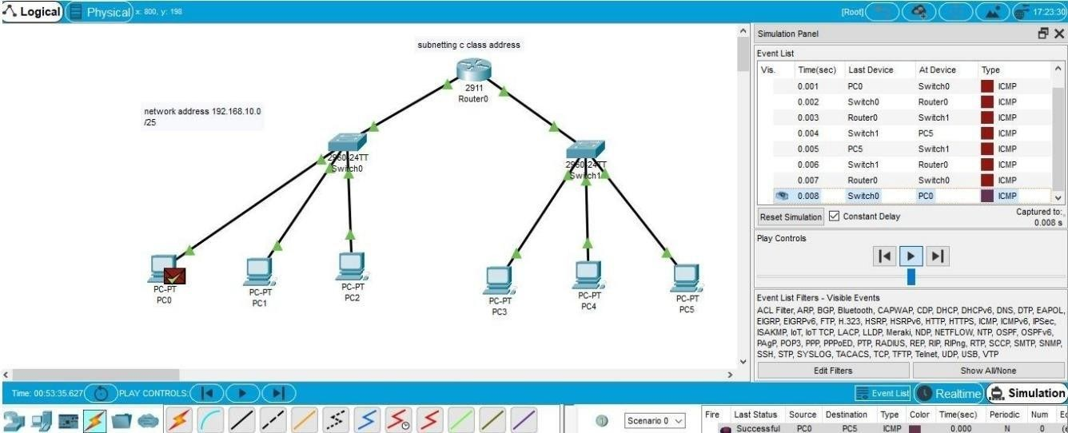

12.Design the Functionalities and Exploration of TCP using Packet Tracer.
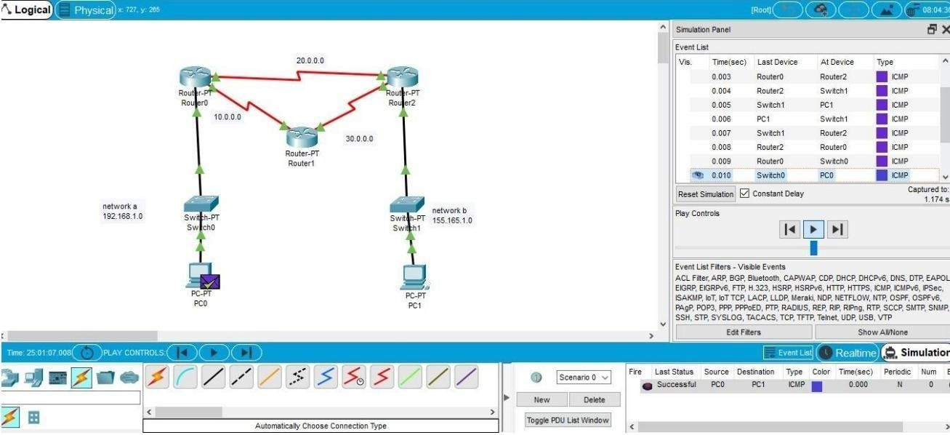

13.Design the network model for Subnetting – Class C Addressing using Packet Tracer.

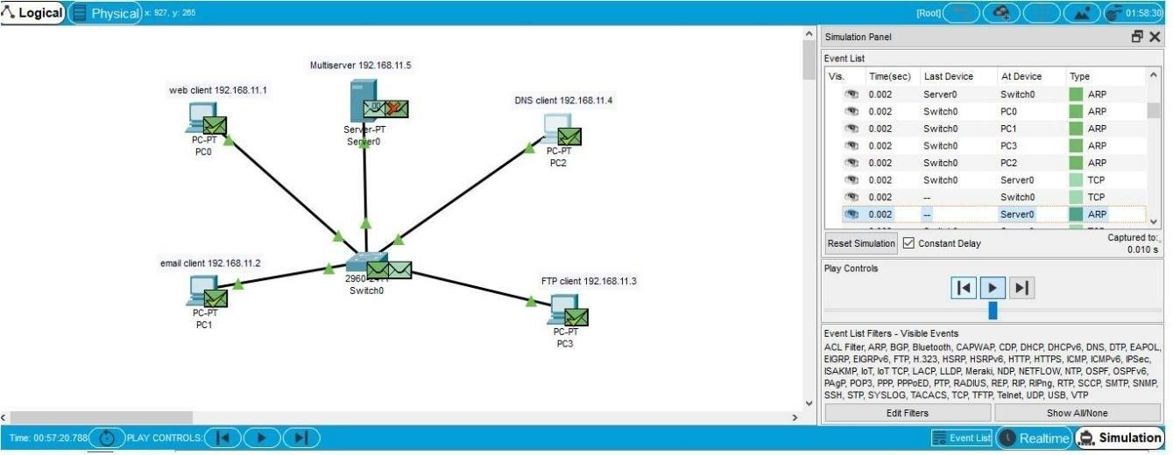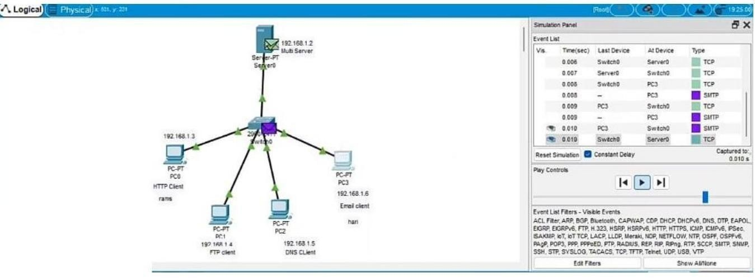

14.Simulating X, Y, Z Company Network Design and simulate using Packet Tracer.

